Scenario 1: Mapping 5 parameters to top 5 Quarters

For any refernce go through this link :
http://www.tableauexpert.co.in/2015/06/scenario-1-mapping-5-parameters-to-top.html

Steps :

1. Create a calculate field named has Quarter

RIGHT(STR(YEAR([Order Date])),2)+'Q'+DATENAME('quarter',[Order Date])

2. Create a calculate field named has Rank Quater

RANK(ATTR([Quarter]))

3. Create a parameter named has CQ(Current Quarter)

Name : CQ
Data Type: Integer
Current Value : 0

4. Create another four paramters same like CQ named has LQ1, LQ2, LQ3, LQ4

5. Create a calculate field named has Uplift_Sales

IF [Rank Quarter]=1 THEN SUM(Sales)+(SUM(Sales)*([CQ]/100))
ELSEIF [Rank Quarter]=2 THEN SUM(Sales)+(SUM(Sales)*([LQ1]/100))
ELSEIF [Rank Quarter]=3 THEN SUM(Sales)+(SUM(Sales)*([LQ2]/100))
ELSEIF [Rank Quarter]=4 THEN SUM(Sales)+(SUM(Sales)*([LQ3]/100))
ELSEIF [Rank Quarter]=5 THEN SUM(Sales)+(SUM(Sales)*([LQ4]/100))
END

6. Drag Quater field into filter shelf and select top 5 Quaters with Maximum.

7. From Filter shelf drag the Quater field with ctrl into columns.

8. Now drag sales and uplift sales into rows.

9. In marks card select Line graph and make the dual axis with synchorinze axis.

10. show the all the paramter controls of CQ, LQ1,LQ2, LQ3, LQ4.

11. Pass the different values through paramter controls.

12. Now it display the desired result with Mapping 5 parameters to top 5 Quarters.
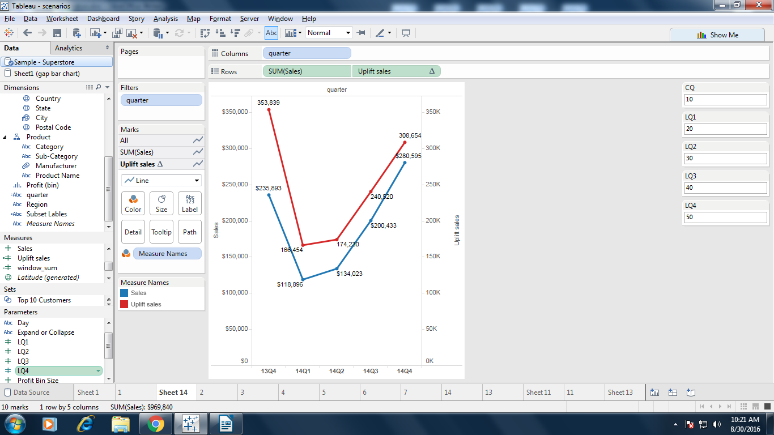

Scenario 2: Gap Analysis using floating Bar chart

For any refernce go through this link :
http://www.tableauexpert.co.in/2015/06/scenario-2-gap-analysis-using-floating.html

Steps:

1. Drag Quarter dimension into Columns

2. Drag Demand, Supply measures into rows

3. Goto Showme , Select side by side chart.

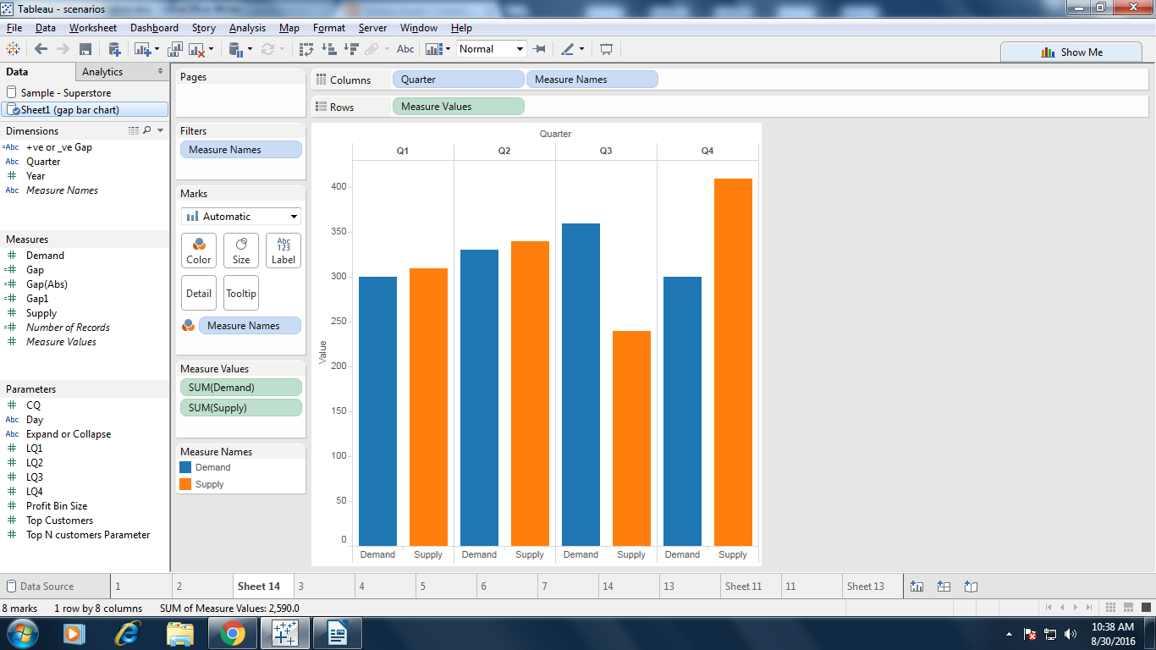

4. Create a calculated field Gap to make the starting point of floating bar.
IF SUM([Supply])>SUM([Demand]) THEN FLOAT(SUM([Demand]))
ELSE FLOAT(SUM([Supply]))
END

5. Drag Gap into rows.

6. Right click on Gap axis and select dual axis.

7. Right click on “Gap” axis which on right side and select “Synchronize Axis”, again right click and
click on Show Header. Then the right side Axis will go hide.

8. Go to Marks shelf, select “Gantt Bar” in Gap marks shelf drop down.

9. Create a calculated field as “Gap (ABS)” to get the Absolute value of Gap.
FLOAT(ABS([Supply]-[Demand]))

10. Drag “Gap (ABS)” field in to size shelf. Now you will see floating gap bars in chart.

11. Create a calculated field for conditional formatting as “+ve or -ve Gap”

IF ([Supply]-[Demand])<0 then "-ve Gap" else "+ve Gap" END

12. Drag +ve or -ve Gap into Gap marks shelf in color card.

13. Drag Year into filter shelf and right click Year select show filter

14. Now we have to show labels to bars. Just click on “Abc” from tool bar and format labels to
standard format.

15. See the label for gap floating bar it showing either Demand or Supply values because we use them
for starting point of float bar. So we need to change this label. Go to label shelf of Gap marks shelf,
unchecked show mark labels.

16. create a calculated field "Supply - Demand (Gap)"

[Supply]-[Demand]

Now Drag “Supply - Demand (Gap)” field in to label shelf of Gap Marks Shelf.

17. Finally report is completed.

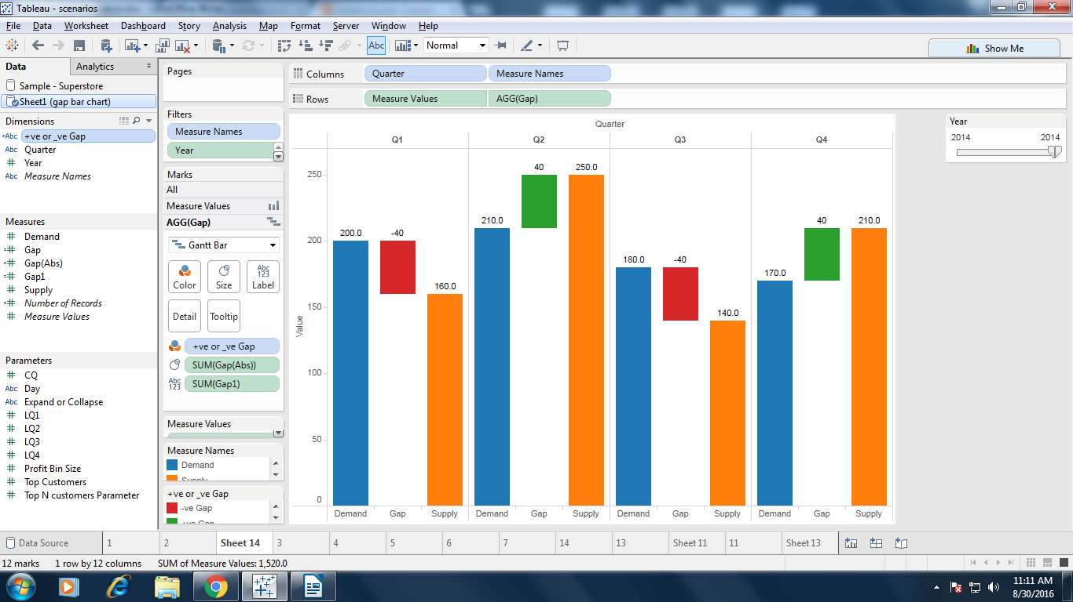

Scenario 3: Removing Subtotals for unwanted columns.

For any refernce go through this link :
http://www.tableauexpert.co.in/2015/06/scenario-3-removing-subtotals-for.html

Steps :

1. Create a cross tab report like, Region, Subcategory, Category, shipmode, Segement drag into rows.

2. Goto toolbar Analysis, select Total => Add all subtotals.

3. Right click on Region column which is there in row shelf to remove subtotals. By default it is
selected, Click on Subtotals to remove subtotals.

4. Repeat step 3 for Subategory column to remove subtotal.

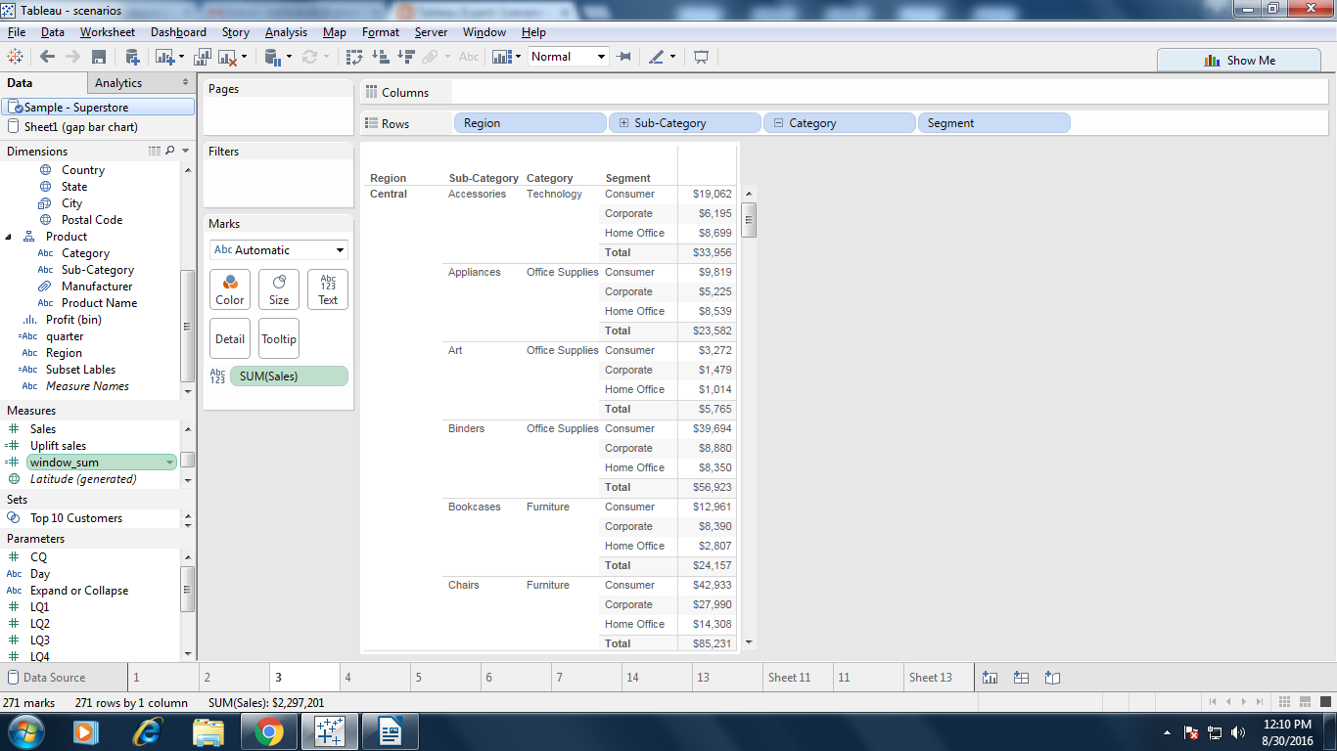

Scenario 4: Applying filters only for numerator, not for denominator using FIXED( ).
For any refernce go through this link :
http://www.tableauexpert.co.in/2015/06/scenario-4-applying-filters-only-for.html

Steps:

1. Create a calculate field for Numerator

COUNTD([Order ID])

2. Create a calculate field for Denominator

{ FIXED [Segment], [Region] : COUNTD([Order ID]) }

3. Drag Segment, region into row shelf.

4. Drag Numerator, Denominator into text shelf.

5. From show me, select Text Table

6. Drag Year, Category into filter shelf and also shows the show filter of both.

7. Right click Year on filter shelf , select context filter.

8. Now change the multi value list of Category it effects only Numerator.

9. If we changes on Year it will effects the both Numerator and Denominator.

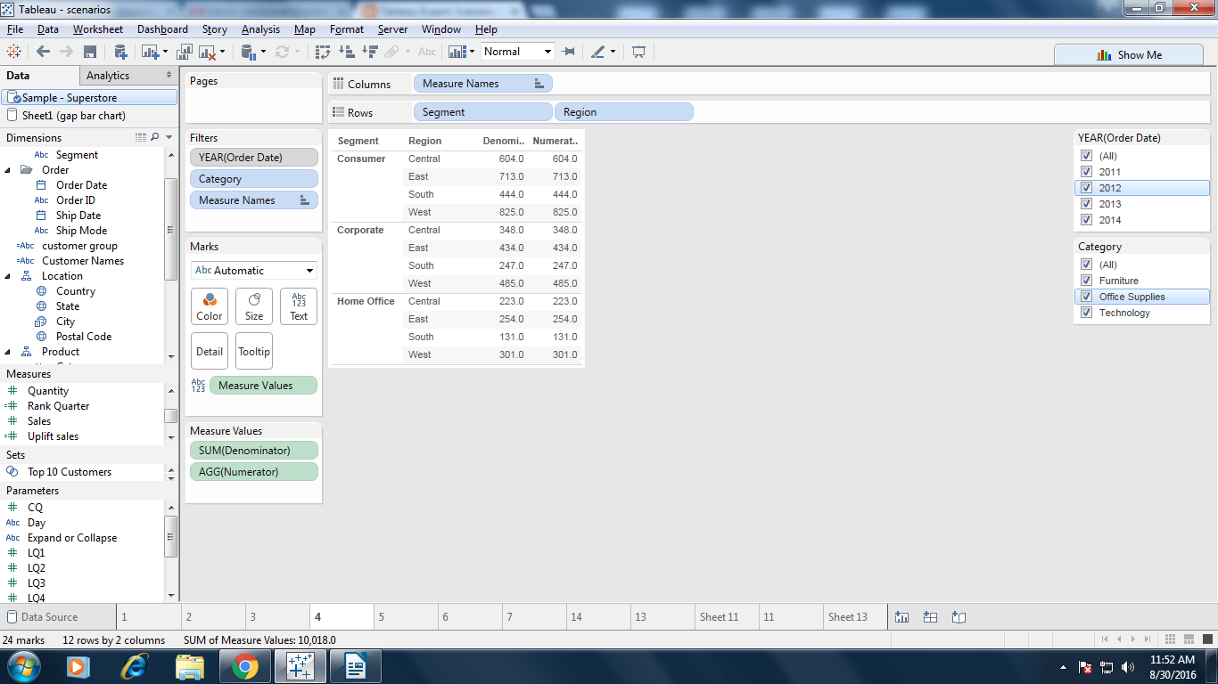

Scenario 6: Showing Sum(sales) for pane with out repeating same value
For any refernce go through this link:
http://www.tableauexpert.co.in/2015/07/scenario-6-showing-sumsales-for-pane.html

Steps:
1. Create a calculated field named as window_sum
if LAST()=0 THEN WINDOW_SUM(SUM([Sales]))
ELSE NULL
END
2. Drag Customer Segment, Region, Sales and window_sum to row shelf.
3. Goto Show me , select text table
4. Right click on window_sum in the marks card, select compute using => pane down
5. Now the desried result display Sum(sales) for pane with out repeating same value.
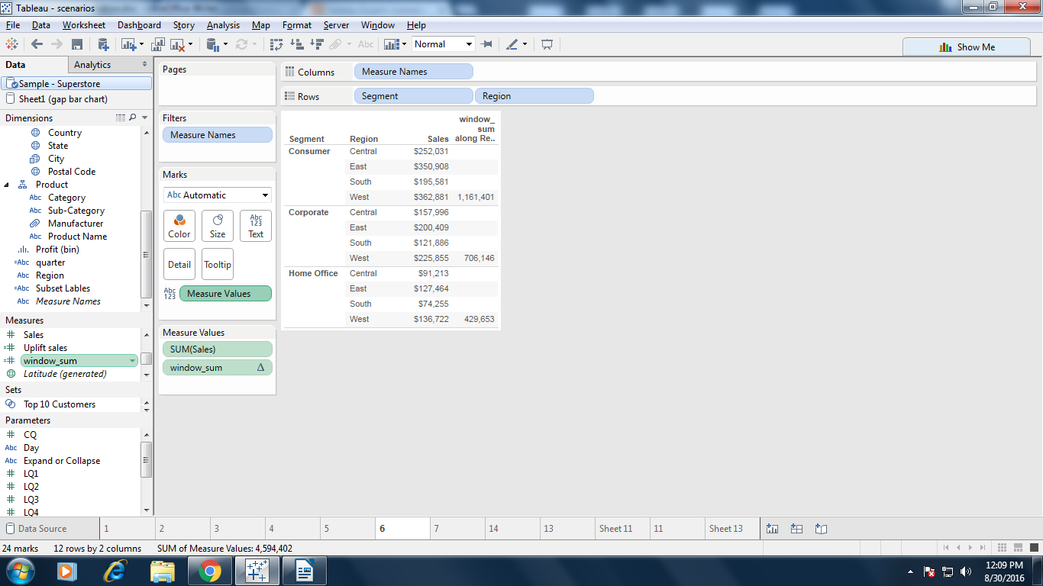

Scenario 5: Showing inventory for selected day if not selected then show last day inventory by month

Wise.
For any refernce go through this link:
http://www.tableauexpert.co.in/2015/07/scenario5-problem-showing-inventory-for.html

Steps:
1. Create parameter Day(parameter) with data type as string.
2. Drag Month, Day to row shelf.
3. Show the parameter contorl of Day(parameter).
4. Create a calculate field named has Max or Selected day
if Day(parameter) = ' ' then window_max(max([Day]))
else int(Day(parameter)) end
5. Drag this newly created calculated field Max or Selected day to text marks shelf.
6. Now right click on Max or Selected day which is there in text marks shelf and go to
Compute using => pane(down).
7. Create one more calculate field as Max day filter.
If attr(Day) =[Max or selected day] then "True" Else "False" END
8. Now drag [Max or selected day] column to filter shelf and select only True.
9. Remove column Max or selected day from marks text shelf and add Stock in inventory
column to marks text shelf.
10. Now it display the inventory for selected day if not selected then show last day inventory by month
wise.

Scenario 7 How to make % of Total Sales consistent after applying filter
For any refernce go through this link:
http://www.tableauexpert.co.in/2015/08/scenario-7-how-to-make-of-total-sales.html

Steps:
1. Create a calculated field as Fixed Sales
(fixed : sum([Sales]))

2. Create a calculated field as % of Total Sales

sum([Sales])/sum([Fixed Sales])

3. Drag Region to row shelf and % of Total Sales to Text shelf.

4. Drag Region to filter shelf and show it as quick filter.

5. Right click on Agg(% of Total Sales), go to format options, change number format to percentage.
6. Now you will see sales in percentage.
7. Change the filter and see that percentage is not changing.
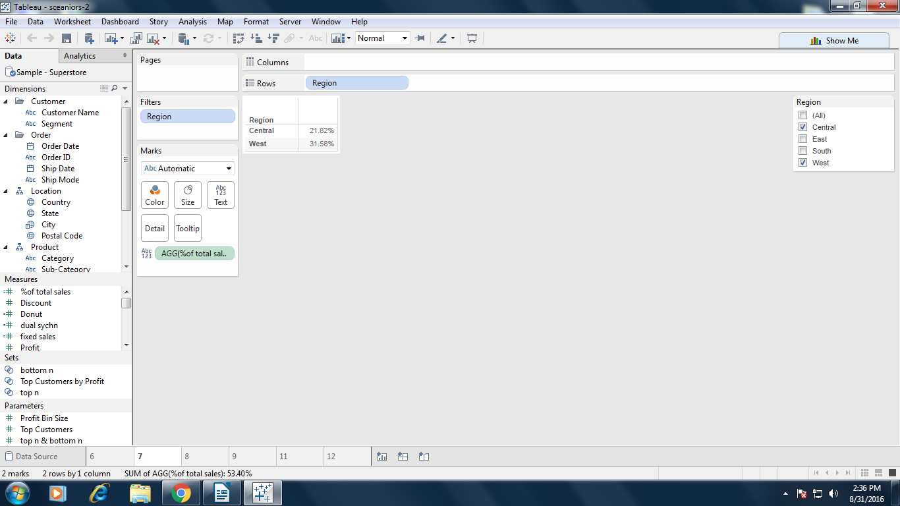

Scenario 8 How to calculate Year over Year Growth when quarter are

like 15Q1, 15Q2......
For any refernce go through this link:
http://www.tableauexpert.co.in/2015/08/how-to-calculate-year-over-year-growth.html

Steps:
1. Create a calculated field as Year_Quater
RIGHT(STR(YEAR([Order Date])),2)+'Q'+STR(DATEPART('quarter',[Order Date]))
2. Drag Year_Quater filter shelf and select Top 5 Quarters.
3. Drag Year_Quater from filter shelf to with ctrl into row shelf and Region into column shelf.
4. Create a calculated field as Year over Year Growth
(sum(Sales)-lookup(Sum(Sales),-4))/lookup(Sum(Sales),-4)
5. Drag Year over Year Growth into Text Shelf.
6. Right click on Year over Year Growth, selct compute using => Table down
7. Right click onYear over Year Growth field which is there in text shelf and change number format to percentage.
8. Create a Calculate filed Show Last Row
if last() = 0 then "Show" else "Hide" END
9. Drag Show Last Row field to filter shelf and select Show
10. Right click on Show Last Row which is there in filter shelf, go to compute using and select Table Down then it will pop up once again for filter selection. Select Show Click OK button.

